EMILY GOLDING-ELLIS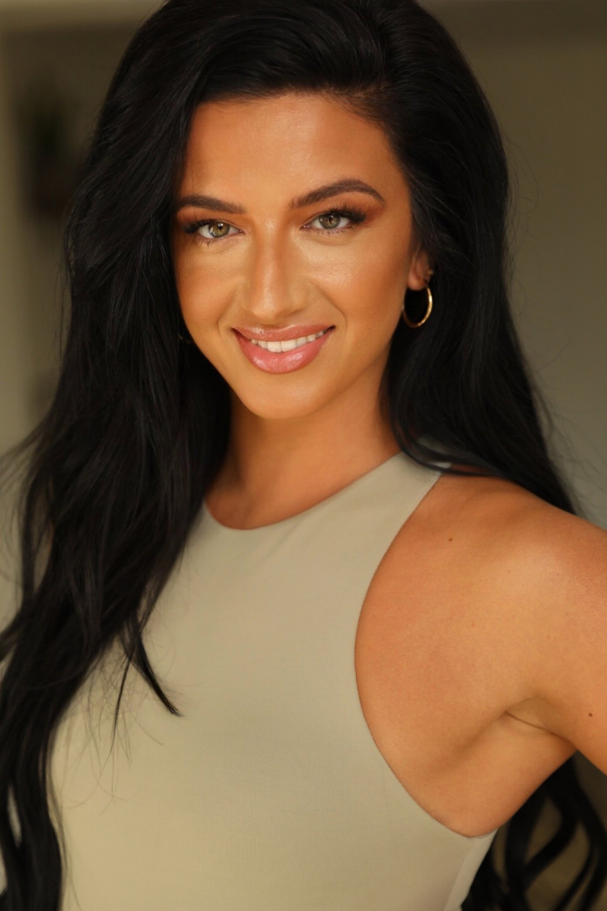

**Email:** [emilygoldingellis@googlemail.com](mailto:emilygoldingellis@googlemail.com)

**Phone:** 07523259654

**Location:** London/Swindon

**Socials:** @emilygoldingellis_

**Playing age:** 25-35

**Height:** 5ft7

**Hip:** 31”

**Bust:** 34”

**Build:** Athletic

**Eye Colour:** Green

**Shoe:** UK 6

# Role Production/Type Creative/Agency

Dancer/Dance Captain Artist World Tour - Bring Me The Horizon BMTH LTD

Dancer Brit Awards - Ed Sheeran Gareth Walker/Mass Talent

Dancer Dance 100 - Netflix Liam Lunniss / CDM Agency

Dancer ITV - Dancing on Ice Briony Albert/Mass Movement

Dancer Alan Carr Show - Sugababes Kenrick Sandy/Boy Blue Ent

Dancer Aditya Birla Awards - Saudi Nathan Clarke/Mass Talent

Dancer King’s Cup Final - Saudi Mark Jennings/Mass Talent Dancer/Skeleton crew BBC - Dance Date Show Briony Albert/Gaz Davis/Mass  
Dancer Cannes - Boo Productions Myron Birch/Jo Dyce   
Dancer/Swing Coppelia - KVNDance Company Kevon Allen

Dancer/Dance Captain Reading Festival - Ed Sheeran BMTH LTD  
Dancer/Dance Captain New Music Awards - BMTH BMTH LTD   
Dancer/Dance Captain BBC Radio 1 Big Weekend - BMTH BMTH LTD   
Dancer/Dance Captain Glastonbury - BMTH BMTH LTD   
Dancer/Dance Captain Lollapalooza - Chicago - BMTH BMTH LTD

Dancer Fenty Beauty Launch - Rihanna Lyndon Llyod/United Productions

Dance Captain Sony - Music Video - Alissic Sony

Dancer Ferrari World Supple Nam/SN Casting

Dancer/Model London Fashion Week - A Cold Wall Samuel Ross Dancer/Dance Captain Playstation 4- Los Angeles-Music Video BMTH LTD Dancer Anne Summers - Online commercial Philip Birchall

Dance Captain BP Pulse - Online Commercial/TV Lyndon Llyod/United Productions Dancer/Dance Captain Oddbins - Online commercial CDM Agency

Dancer Nike - Online commercial Kenrick Sandy/Boy Blue Ent  
  
Dancer/Model Mecca Bingo - Social media commercial TagLive

*Page 1 of 2*

|  |  |  |
| --- | --- | --- |
| Dancer | Thriller Live - UK/Europe/China Tour | Gary Lloyd |
| Dancer | BBC Drag Race Queens - Tales of the Condemned - UK Tour | Lyndon Lloyd/United Productions |
| Dancer | Google | Scarlett Entertainment |
| Dancer/Dance Captain | Greatest Showman | Scarlett Entertainment |
| Dancer/Dance Captain | Robe Lighting Convention - Germany | Robe LTD |
| Dancer | Jwerkz - Los Angeles - Music Video | Zara Richards |
| Dancer/Dance Captain | Bisola - Music Video | Bisola Music LTD |
| Dancer | Kima Otung - Music Video | Dominic Hamilton/Corded UK |
| Dancer/Dance Captain | Asya - Music Video | Oliver Brian Productions |
| Dance Captain | J.Fla - Music Video | Lyndon Lloyd/United Productions |
| Dance Captain | Salon International - Mahogany Hair | Louise sewell |
| Dancer/Dance Captain/Hair Model | Lanza Haircare - Live show | Zoe Desmond |
| Dancer/Model | Nike/Tottenham FC - Season Kit Launch | Nicola Brown / Louis Mackay |
| Dancer/Model | Southampton FC - Season Kit Launch | Bec Models |
| Dancer/Model | Asos - A&M Official | Rapunzel Swr |

# Training:

2024 Blueprint - Kieran Donovan

2021-2023 Dancers Inc/Phase Josh Wharmby/ Los Angeles 02/10/2021 Sharon June Intensive, London

01/09/2020 Jay Revell BlackSkull Intensive, London 01/07/2020 Nikki Trow Intensive, London 17/03/2019 Dancer Inc Intensive, London 20/08/2018 Millennium Dance, Los Angeles 27/11/2017 Dean Lee Intensive, London